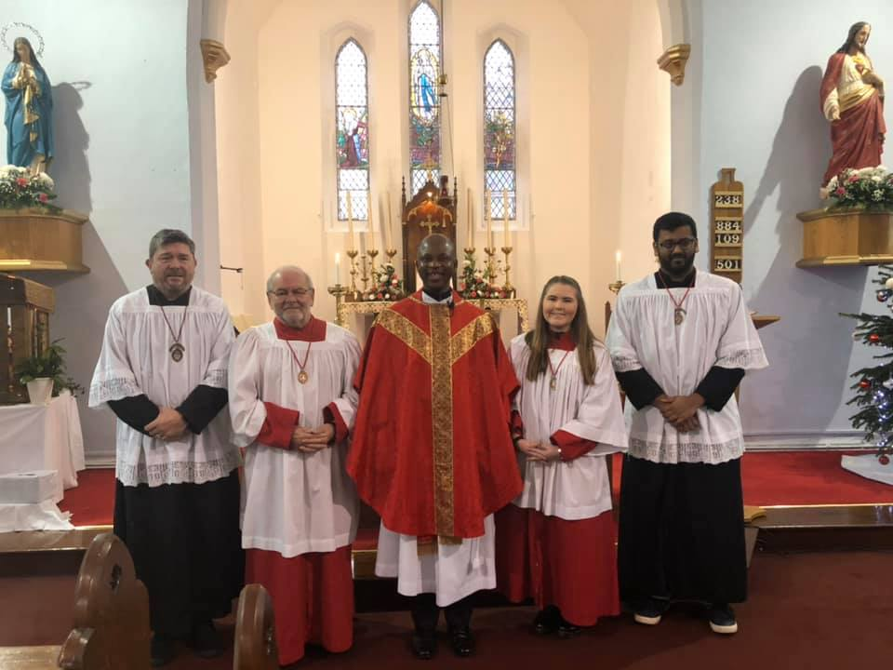
Father Richard and altar servers at Immaculate Conception on 26 December 2019. Feast of St Stephen.
(We now need a lovely photo for all the servers in All Saints!)

